

CSA0501-DATABASE MANAGEMENT SYSTEMS

LAB EXPERIMENTS DATE: 22/07/2026

EXPERIMENT 8 – Query with Sub Query & Correlated Query
AIM: To perform Sub Query and Correlated Query on the Pet Management System database.

PROCEDURE:
- Open MySQL and select the pet_management database.
- Display all records from the pet_details table.
- Execute queries using subqueries.
- Execute correlated subqueries using the EXISTS clause.
- Verify the output and record the results.
PROGRAM:

1. Display all records:

USE pet_management;

SELECT * FROM pet_details;

OUTPUT:

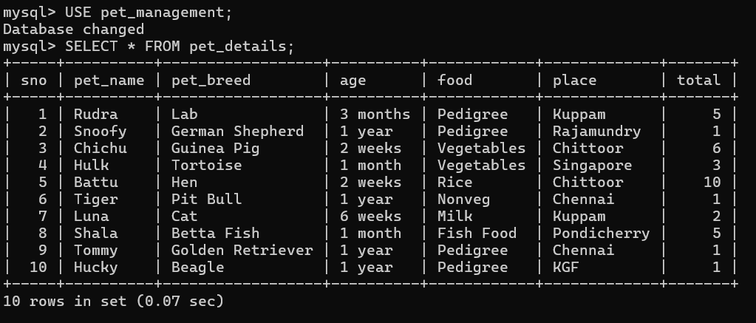

2. Sub Query
Display pets whose total is greater than the average total
SELECT *
FROM pet_details
WHERE total >
(SELECT AVG(total) FROM pet_details);
OUTPUT:

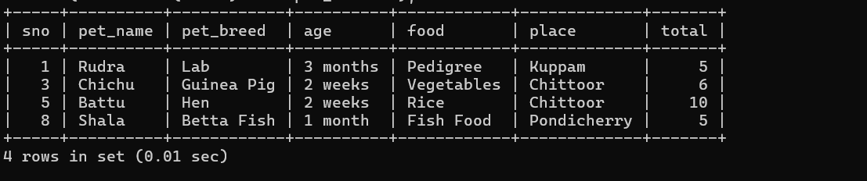

3. Sub Query
Display pets whose food is the same as 'Rudra'
SELECT *
FROM pet_details
WHERE food =
(SELECT food
FROM pet_details
WHERE petsname='Rudra');
OUTPUT:

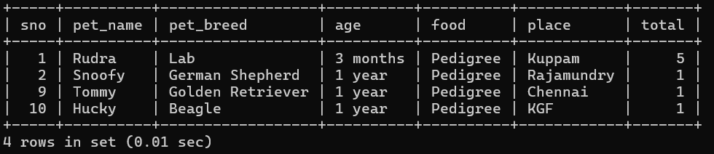
4. Correlated Query
Display pets whose total is greater than the average total of pets with the same food type
SELECT *
FROM pet_details p1
WHERE total >
(
SELECT AVG(total)
FROM pet_details p2
WHERE p1.food = p2.food
);

OUTPUT:

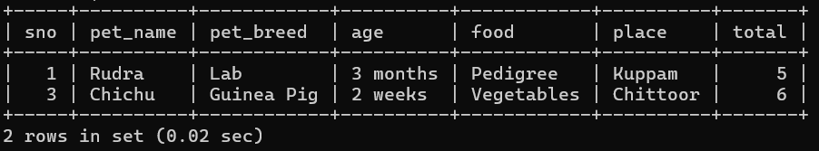

RESULT: The Sub Query and Correlated Query were executed successfully on the Pet Management System database, and the required records were displayed correctly.

